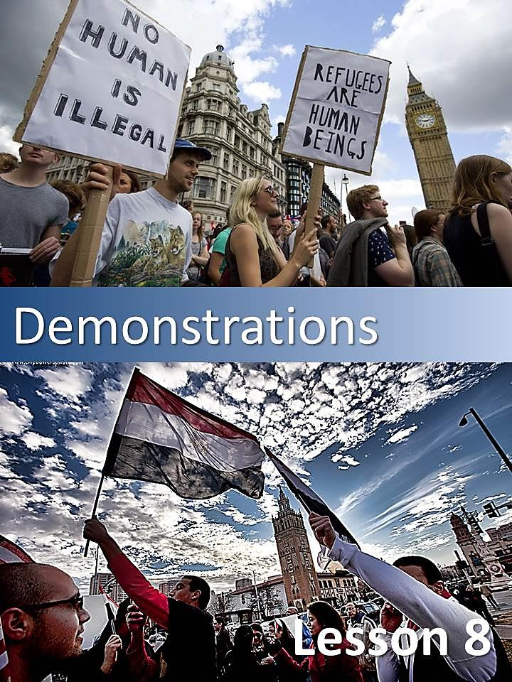

* Answer the following questions in Spanish.

1. Have you ever gone on a demonstration?
2. What do you know about “No Planet B” demonstrations??

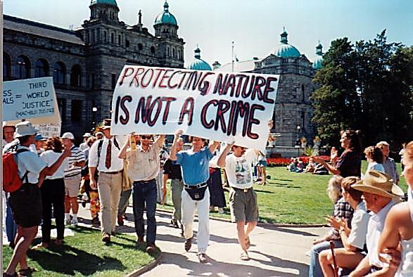

*  Read the following article carefully and state the main idea of each paragraph.

### Demonstration

Sun Nov 29, 2015

PARIS/PERTH, AUSTRALIA | BY MEGAN ROWLING AND MORAG MACKINNON

**'No Planet B,' marchers worldwide tell leaders before U.N. climate summit.**

More than half a million people from Australia to Paraguay joined the biggest day of climate change activism in history on Sunday, telling world leaders gathering for a summit in Paris there is "No Planet B" in the fight against global warming.

In the French capital, where demonstrations were banned by the authorities after attacks by Islamic State militants killed 130 people on Nov. 13, activists laid out more than 20,000 shoes in the Place de la Republique to symbolize absent marchers on the eve of the summit.

Among the high heels and sandals were a pair of plain black shoes sent by Pope Francis, who has been a vocal advocate for action to prevent dangerous climate change, and jogging shoes from U.N. Secretary-General Ban Ki-moon.

One activist, dressed in white as an angel with large wings, held a sign saying "coal kills". About 10,000 people joined arms to form a human chain through Paris along the 3-km (2-mile) route of the banned march, organizers said.

**ARRESTS IN PARIS**

French police detained scores of protesters after violent clashes in central Paris on Sunday though, a day before the official start of conference that aims to tackle global warming.

Riot police used tear gas to disperse about 200 protesters, some of them masked, who responded by hurling rocks and even candles. French President Francois Hollande accused the violent protesters of dishonoring the memory of the dead.

The U.N. climate change conference is taking place at Le Bourget just outside Paris. Initial talks among negotiators began on Sunday.

**PROTESTS AROUND THE WORLD**

More than 2,000 events were held in cities including London, Sao Paulo, New York and Asuncion, Paraguay, on the eve of the Paris summit which runs from Nov. 30-Dec. 11 and will be attended by about 150 heads of government.

About 683,000 people attended the rallies around the world, said Sam Barrat, a spokesman for Avaaz, one of the organizers.

"And this was done even without Paris," after the March there was banned, he said,

Around the world, activists marched, dressed as polar bears or penguins at risk from melting ice, or chanted slogans such as "climate justice".

Organizers said that 570,000 people so far had taken part in rallies worldwide and that they expected demonstrations including in Ottawa and Mexico City later in the day to push the count above 600,000.

"These are the biggest set of global marches in history," said Sam Barratt at Avaaz.

There was no independent verification of the numbers, although none of the individual marches rivaled one in New York last year that drew an estimated 310,000 people.

In Sydney, about 45,000 people are estimated to have marched through the central business district toward the Opera House. Protesters held placards reading: “There is no Planet B,” and “Say no to burning national forests for electricity”.

In London, organizers said 50,000 marchers were joined by fashion designer Vivienne Westwood, actress Emma Thompson and opposition Labour leader Jeremy Corbyn, who said the turnout was especially impressive for a wet November Sunday.

In New York, hundreds of people, many of them holding signs calling for aggressive measures to stop global warming, marched around the perimeter of New York City Hall in lower Manhattan.

**OBAMA AND XI JINPING IN PARIS**

U.S. President Barack Obama and China's Xi Jinping will be among the leaders attending the start of the summit, which organizers hope will produce a legally binding agreement to commit both rich and developing nations to curbing emissions of greenhouse gases, blamed for warming the planet, beyond 2020.

Hopes are high that the Paris summit will not fail like the previous such meeting six years ago in Copenhagen.

Popular and political momentum for tougher action on carbon emissions has accelerated in recent years, with 2015 set to be the warmest on record. Activists are seeking to combat everything from Beijing’s smoggy skies to Canada’s Keystone oil pipeline.

Saiba Suso, a 26-year-old demonstrator in Paris, said the poor were most at risk: "We are paying the price and we are not the cause. The industrialized countries owe us a lot."

Still, all sides say pledges made in Paris will be insufficient to limit a rise in global temperatures to 2 degrees Celsius (3.6 Fahrenheit) above pre-industrial levels, widely viewed as a threshold for dangerous changes in the planet's climate system.

* Read the article again and answer the following questions.

1. What does “No Planet B” refer to?
2. Where and when did the demonstration take place?
3. Whose shoes did the activists lay out in the Place de la Republique?
4. Why were Pope Francis’ shoes there?
5. Who were arrested? Why?
6. Where else were demonstrations held?
7. What did activists expect from the leaders attending the summit?

#### http://www.literautas.com/es/blog/wp-content/uploads/eye-magnifying-glass-book.gifRevision

* Find examples in the text and complete the chart.

|  |  |
| --- | --- |
| **Relative clause** |  |
| **Passive voice** |  |
| **Existence** |  |
| **Comparative** |  |
| **Superlative** |  |

* Underline prefixes and suffixes in the following examples taken from the text.

|  |  |  |  |
| --- | --- | --- | --- |
| global warming  activists  insufficient | agreement  organizers  dishonoring | smoggy  individual  pre-industrial | demonstration  official |

#### GRAMMAR IN USE

* Complete the following tables with examples from the text.

| **Tense** | **Example**  (in English) | **Functions / Uses**  (in Spanish) |
| --- | --- | --- |
| Simple Present |  |  |
| Present Continuous |  |  |
| Simple Past |  |  |
| Present Perfect |  |  |
| Past Perfect |  |  |
| Future Simple |  |  |

* Answer the questionare to see if you are environmentally aware.

### Are you part of the problem?

1. 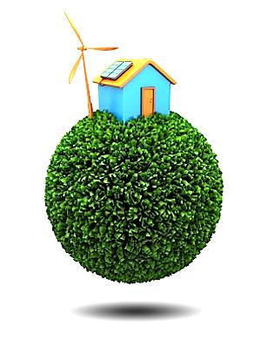Whenever you leave a room, do you….
   1. Turn off all the lights?
   2. Leave one light on?
   3. Never bother to turn off the lights?
2. Wherever you have to go, do you…
   1. Walk or ride a bike?
   2. Take public transport?
   3. Travel by car?
3. Whatever you don´t use, do you…
   1. Separate the ones you can recycle?
   2. Classify the rubbish?
   3. Throw all the rubbish in the same bin?
4. Whoever is smoking in your house, do you…
   1. Ask him/her to put the litter in the bin?
   2. Ask him/her not to smoke?
   3. Let him/her throw the litter on the ground.

Your answers means:

**Mostly a’s:** You are helping our planet! Keep up the good work.

**Mostly b’s:** There are more things that you could do for the planet. Come on!

**Mostly c´s:** Every little bit can help our world a better place for everyone.

#### MC900404011[1]Palabras relativas con el sufijo EVER

El sufijo -EVER se adjunta a ciertas palabras relativas WHO / WHOSE / WHOM / WHICH / WHERE / WHAT con el fin de expresar el sentido de 'no importa qué', 'todo':

|  |  |  |  |
| --- | --- | --- | --- |
| ***E.g.*** | *Whichever decision you make, I'm sure it will be the right one.* | Cual sea la decisión que tomes, estoy seguro que será la mejor. | **Ej.** |
| *Whoever stole my mug should bring it back immediately.* | Cualquiera que haya robado mi taza debe traerla inmediatamente. |
| *The director will cast whomever he finds suitable.* | El director de la película, dará el papel a quién le convenga. |
| *Whatever he asks for, you should give it to him.* | Pida lo que pida, deberás dárselo. |
| *Whenever she speaks in public she makes a fool of herself.* | Siempre que ella hable en público sentirá que hace el ridículo. |
| *Wherever she goes, she meets him.* | Donde sea que ella vaya, se lo encuentra. |

Podemos encontrar el sufijo -SOEVER después de las palabras relativas, sin embargo, esta construcción es raramente utilizada con who , when y whom :

|  |  |  |  |
| --- | --- | --- | --- |
| ***E.g.*** | *He won't say anything whatsoever.* | Él se niega a decir algo. | **Ej.** |
| *He didn't expect any presents whatsoever.* | Él no espera recibir ningún regalo. |
| *He doesn't want to see his friends whomsoever.* | Él no quiere ver a sus amigos. |